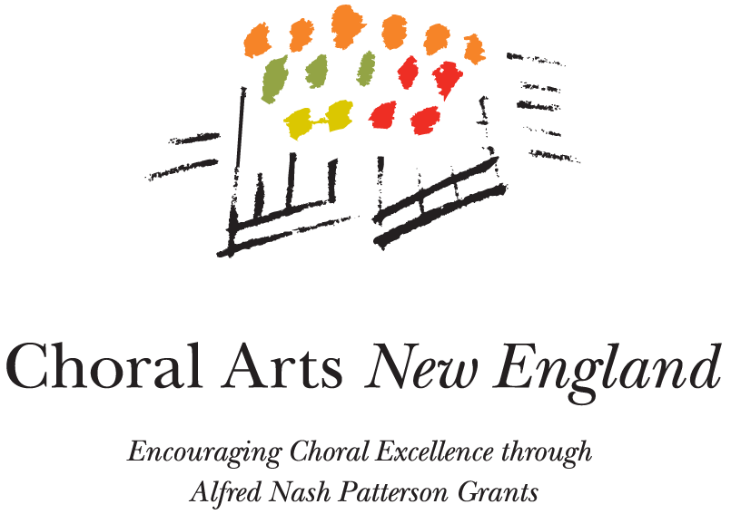
CHORAL ARTS NEW ENGLAND
ALFRED NASH PATTERSON GRANT
PROJECT EVALUATION/REPORT
We are delighted that you have enriched the New England choral community by your project, and hope that our grant was helpful. Please fill out this form to share the news and also to help us better help you and other choral artists!
Completion of this project report form is a requirement of all grant recipients; until the report is submitted, you are not eligible to receive another grant.
Please return the form with any attachments to
Choral Arts New England
P.O. Box 608
Newton, MA 02456-0608
Name of Organization:
Mailing Address:

Contact person:
E-mail:
Preferred telephone:
Project Title:
Date(s) of project or project period:
If an event, how many people attended or otherwise participated?
Actual project expenses: revenues:
PROJECT EVALUATION NARRATIVE
Please attach a brief statement (no more than a single page), telling us how it went.
- Briefly, what happened during the project?
- Did you accomplish your original goals?
- Did you learn anything that you could share with others?
- Would you do it over again, or should there be a next step?
- Are you interested in further publicity for the project (a story in our newsletter)?
ANY SUGGESTIONS for improving the grant process or for other ways we could help?

ENCLOSURES
Please send us, as appropriate:
- publicity examples and program books;
- any reviews or other responses to the project;
- any materials produced;
- any other items you’d like us to see.

